

Destination- Vietnam

No of pax: 2 Adult

No. of nights – 5N 6Days
Hotel: 4*
Package cost Per Adult 54,000 /- Including Service tax.

Complimentary SIM and Insurance

Inclusions:
- 3Night stay at Phu Quoc hotel
- 2Night stay at Danang hotel

- Daily Buffet Breakfast at hotel
- All Inter Hotel transfer on private basis

- Grand World Phu Quoc Evening Tour (Color of Venice Show 21:30 to 22:00) without guide

- Cable Car to Hon Thom Island and Kiss of the Sea Show (30 Minutes Show 21:00 - 21:30; Except Tuesday) without guide (Last Cable Car at 5 PM), Aquatopia water park, Kiss of the Sea Show

- Day Trip to Bana Hills and Golden Bridge (Cable Car, French Village and Fantasy Park)

- Hoi An City Evening Tour with Lantern Boat Ride

- All sightseeing on Private/Sharing basis

- All airport & inter hotel transfer Private Basis

Exclusion:

  - Any compulsory room supplement during the tour

  - Video and Camera permits at sights

  - Meals outside of the stated meal plan

  - Use of vehicle other than the specified itinerary
  - Expenses of personal nature

  - Any other services not specified above

  - Late check-out and Early check-in

Suggested Day wise itinerary
DAY01: As you arrive Phu Quoc airport meet our representative & proceed to the hotel check-in to the hotel, and in the evening ready to Enjoy
Sightseeing Grand World Phu Quoc Evening Tour (Color of Venice Show 21:30 to 22:00) without guide with private basis
Embark on an enchanting evening adventure at Grand World Phu Quoc, where entertainment and excitement await. Explore the vibrant atmosphere of this bustling entertainment complex and create cherished memories under the starlit sky. From dazzling light shows to thrilling rides and immersive experiences, Grand World Phu Quoc offers an unforgettable evening filled with fun and relaxation.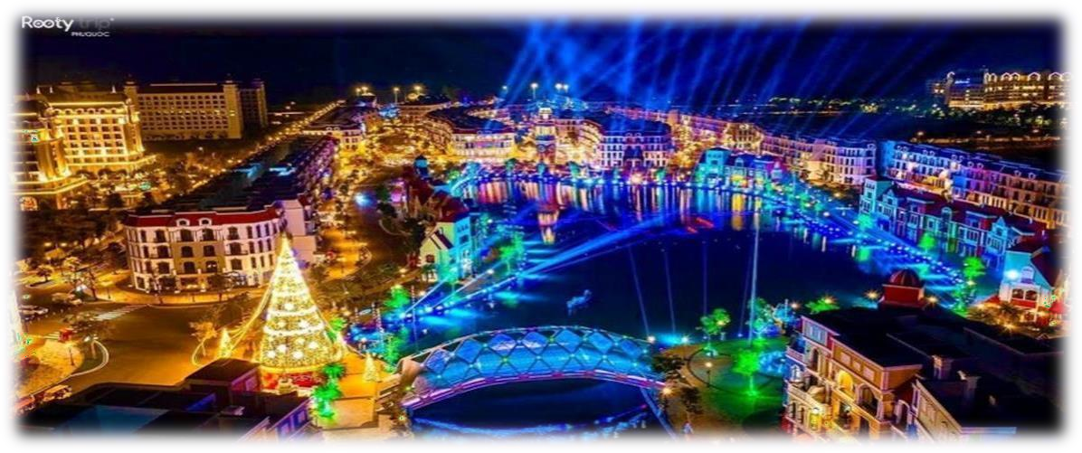

Day02: Have breakfast at the hotel & then ready to Enjoy Sightseeing Cable Car to Hon Thom Island and Kiss of the Sea Show (30 Minutes Show 21:00 - 21:30; Except Tuesday) without guide (Last Cable Car at 5 PM), Aquatopia water park, Kiss of the Sea Show.
ride to Hon Thom Island, where you’ll enjoy breathtaking views of the ocean and surrounding landscapes. After exploring the island, travel to Sunset Town Phu Quoc, where the “Kiss of the Sea” show awaits. This captivating 30-minute performance blends stunning visuals, music, and storytelling. After the show, visit the iconic Kiss Bridge, offering a
romantic atmosphere and spectacular views of the sea. These two tours combine adventure, beauty, and culture for an unforgettable experience in Phu Quoc.
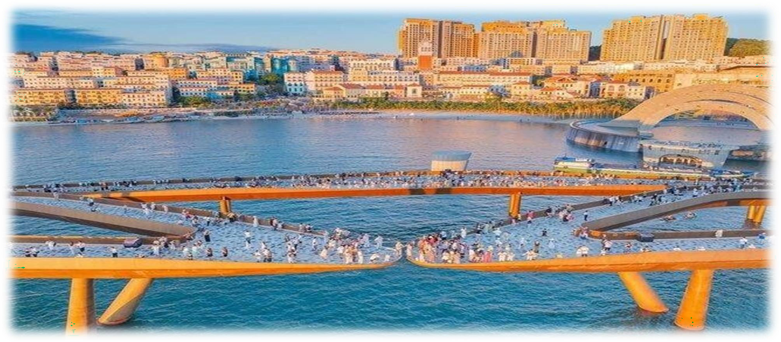

Day03: Have breakfast at the hotel this is your leisure day explore the city by own, overnight at the hotel.

Day04: Have breakfast at the hotel then transfer to the airport reach your next destination Da Nang day time is free for leisure & in the evening get ready for Hoi An City Evening Tour (Ancient Town and Japanese Bridge) with Lantern Boat Ride with & Sharing Basis, Experience the enchanting charm of Hoi An ancient town on our evening tour. Wander through the atmospheric streets adorned with colorful lanterns and admire the iconic Japanese Bridge, a symbol of the city's rich cultural heritage.
Then embark on a magical lantern boat ride along the Thu Bon River where the shimmering lights reflect off the water creating a mesmerizing spectacle.
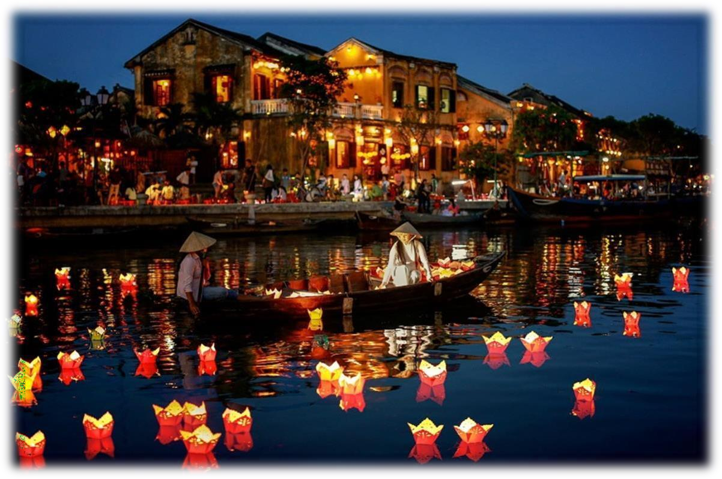

Day05: Have breakfast and get ready Day Trip to Bana Hills and Golden Bridge (Cable Car, French Village and Fantasy Park) | with Lunch SIC Embark on an unforgettable journey to Bana Hills and the famed Golden Bridge on this thrilling day trip. Start by riding the most modem cable car system in Southeast Asia to the mountain peak and enjoy the stunning
Views of Danang city from the Dream Stream Cable car Station. Then visit the awe-inspiring Golden Bridge, a soft and majestic structure designed to look like a silk strip floating in white clouds. Then, discover the Fantasy

Park, an amusement wonderland offering thrilling rides and entertainment for all. Sun World Ba Na Hills ticket includes:
- Round trip cable car

- 1 Ba Na Hills ticket

- Admission to Golden Bridge
- Admission to Le Jardin DAmour Gardens

- Admission to Luna Castle

- Admission to French Village

- Admission to Fantasy Park (Not free for games with coins and awards)

- Admission to Rose garden

Sun World Ba Na Hills ticket excludes:

- Tickets to the Wax Museum, Debay Wine Cellar and Rain Sheltering Teahouse

- Alpine Coaster

- Wowpass, Mountain Climbing

- Food
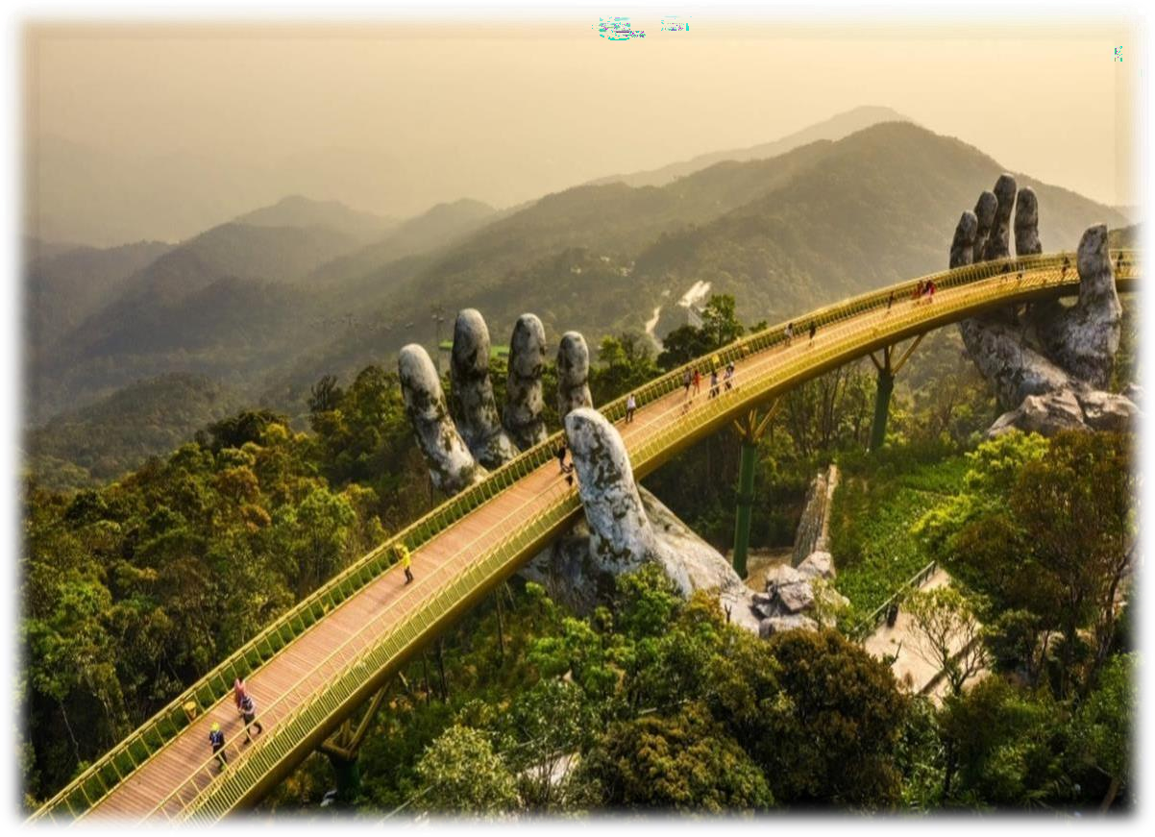

Day06: Have breakfast at the hotel then ready to take transfer to airport according to your flight timings.

